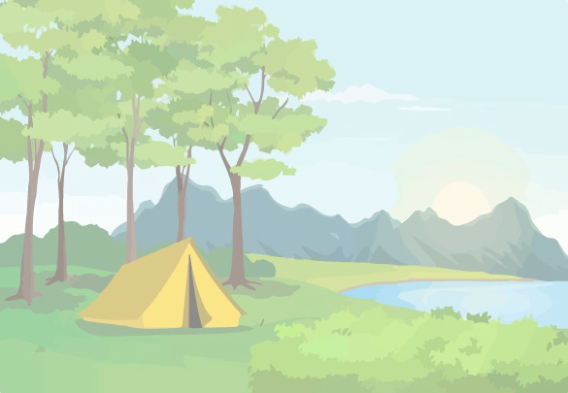

Cub Adventure Day & Fishing Derby 2023

Saturday, September 30, 2023 9am - 2pm
Marion County Lake & Walker Co. Lake
Marion Co. Lake Road Walker Co. Lake Road
Hamilton, AL 35570. Jasper, AL 35501

2023 Cub Scout Adventure Day & Fishing Derby
Saturday, September 30th, 2023
9am – 2pm
Marion County Lake & Walker Co. Lake
Marion Co. Lake Road Walker Co. Lake Road
Hamilton, AL 35570. Jasper, AL 35501
Come to Marion Co. Lake or Walker Co. Lake for a fun-filled day of family scouting!

Adventure activities: Archery • BB Guns • Handicrafts • Scout Skills • Games • and more!!!

Fishing Derby: Bring your fishing pole, tackle, and bait to fish two lakes. Prizes for biggest, smallest, and ugliest fish!

Itinerary: | Opening Flags: | 9:00am | Lunch: | 11:45am – 12:45pm
 | Adventure Activities & Fishing Derby: | 9:15am – 2:00pm | Closing Flags & Awards: | 1:45pm

Families can spend the day as they choose among the many adventure activities or fishing derby, enjoy lunch in the dining hall, and relax and cool off in the shade!

Early Registration: $30 for a scout & parent; $15 for additional scouts; $10 for additional parents/siblings. On-site Registration: $40 for a scout & parent; $20 for additional scouts; $15 for additional parents/siblings.
Registration fees include all adventure activities and an event patch for Cub Scouts, and lunch and fishing derby registration for everyone!

For early registration, please return this portion of the flyer by Friday, September 15 @ 4:00pm to: The Black Warrior Council, Mountain District Cub Scout Adventure Day, P.O. Box 3088, Tuscaloosa, AL 35403
Name of Scout(s) attending: Name of Parent or Guardian:
Phone Number: Email:

Payment |  |  | Lunch Order (one meal / participant) | Number
Scout and Parent/Guardian: |  | $30 | Hot Dog, Chips, Drink, Dessert
Additional Cub Scouts: | x $15 | $ | List food allergies / needed meal accommodations:
Additional Parents/Siblings: | x $10 | $
 | Total: | $______
Please make checks payable to Black Warrior Council, BSA

Contact Darren.hix@scouting.org with any questions.

