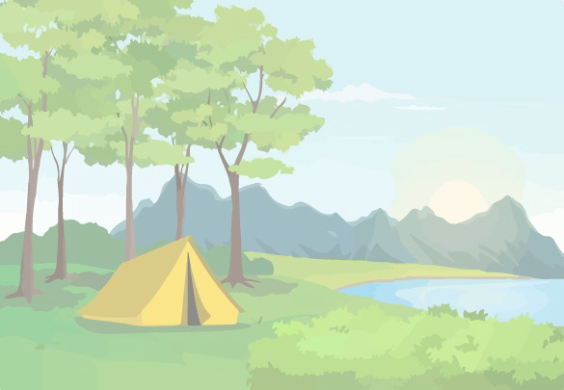
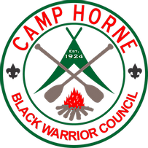
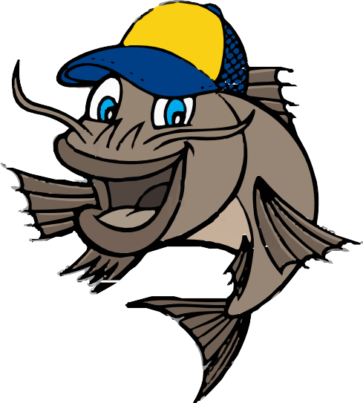

Cub Adventure Day & Fishing Derby 2023

Saturday,
September 30, 2023
8am - 5pm
Camp Horne
13633 Keenes Mill Road Cottondale, AL
Register here

2023 Cub Scout Adventure Day & Fishing Derby
Saturday, September 30th, 2023
8am – 5pm
Camp Horne
13633 Keenes Mill Road, Cottondale, AL
Come explore 500 beautiful acres at Camp Horne for a fun-filled day of family scouting!

Adventure activities: Archery • Rock Climbing Tower • BB Guns • Handicrafts • Rope Making • Scout Skills • S’mores • Games • Trading Post • and more!!!

Fishing Derby: Bring your fishing pole, tackle, and bait to fish two lakes. Prizes for biggest, smallest, and ugliest fish!

Itinerary: | Opening Flags: | 8:00am | Lunch: | 11:45am – 12:45pm
 | Adventure Activities & Fishing Derby: | 8:15am – 4:00pm | Closing Flags & Awards: | 4:30pm

Families can spend the day as they choose among the many adventure activities or fishing derby, enjoy lunch in the dining hall, and relax and cool off in the shade at the Trading Post!

Early Registration: $30 for a scout & parent; $15 for additional scouts; $10 for additional parents/siblings. On-site Registration: $40 for a scout & parent; $20 for additional scouts; $15 for additional parents/siblings.
Registration fees include all adventure activities and an event patch for Cub Scouts, and lunch and fishing derby registration for everyone!

For early registration, please complete the registration QR code or return this portion of the flyer by Friday, September 15 @ 4:00pm to: The Black Warrior Council, River District Cub Scout Adventure Day, P.O. Box 3088, Tuscaloosa, AL 35403
Name of Scout(s) attending: Name of Parent or Guardian:
Phone Number: Email:

Payment |  |  | Lunch Order (one meal / participant) | Number
Scout and Parent/Guardian: |  | $30 | Pasta Bake, Salad, Garlic Bread, Drink, Dessert
Additional Cub Scouts: | x $15 | $ | Hot Dog, Chips, Drink, Dessert
Additional Parents/Siblings: | x $10 | $ | List food allergies / needed meal accommodations:
 | Total: | $______
Please make checks payable to Black Warrior Council, BSA

Contact ecwestern@gmail.com with any questions.

